Blinkit Grocery Sales Dashboard

The Blinkit Grocery Dashboard is a Power BI project designed to analyze and visualize grocery sales and operational performance for a quick-commerce platform like Blinkit. The dashboard provides a centralized view of key business metrics such as total sales, total orders, average order value, top-selling products, and category performance.
Data was cleaned and transformed using Power Query. Interactive visuals like KPI cards, line charts, bar charts, pie charts, and tables help track sales trends, customer demand, and product performance.
This dashboard helps business users identify growth trends, understand customer behavior, optimize inventory, and support faster data-driven decisions.
Introduction
The Blinkit Grocery Dashboard is a Power BI–based analytics project developed to monitor and evaluate the sales and operational performance of a quick-commerce grocery platform. With increasing order volumes and the need for rapid decision-making, this project provides a single, interactive dashboard to track key metrics such as sales, orders, customer behavior, and product performance.
By transforming raw grocery data into meaningful visual insights, the dashboard enables stakeholders to identify trends, compare category performance, understand customer demand, and improve business efficiency. The project focuses on delivering clear, actionable insights through well-structured data modeling and intuitive visualizations, supporting data-driven decisions across sales and operations.

Dashboard Landing Page

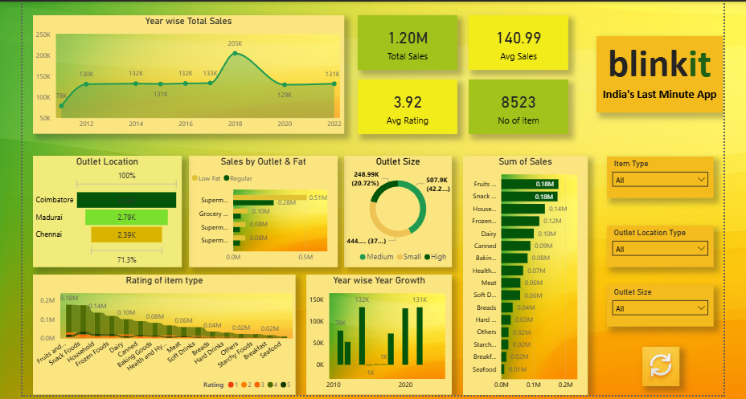
Problem Statement
Blinkit operates in a fast-paced quick-commerce environment where thousands of grocery orders are placed daily across multiple categories and locations. Although large amounts of data are generated, the business lacks a centralized and automated reporting system to analyze sales performance, customer behavior, and product demand in real time.
Existing reports are largely manual and fragmented, making it difficult for stakeholders to:
- Track overall and category-wise sales trends
- Identify top- and low-performing products
- Understand customer purchasing patterns
- Monitor key performance indicators consistently
- Which year recorded the highest total sales?
- Which outlet size contributes the most to total sales?
- Which outlet location tier generates the highest revenue?
- Which item category has the highest sales?
- Which item type are high sales?
- Which outlet type performs best in terms of total sales?
- Which item type has highest rating?
Existing System

In the existing system, Blinkit’s grocery sales and operational data is handled using traditional and semi-manual reporting methods. Data from different business operations such as orders, products, customers, and outlets is stored in separate files or databases, often exported into Excel sheets for analysis. There is no unified platform that combines all this information into a single, consistent view.
Because of this approach:s
- Sales and order analysis is slow and repetitive
- Tracking KPIs requires manual calculations
- Insights on customer behavior and product performance are delayed
- Decision-making is based on historical data rather than real-time trends
Report preparation requires significant manual effort, including data cleaning, filtering, and calculations. KPIs like total sales, order count, and average order value are calculated separately each time, increasing the risk of human errors and inconsistencies. Since reports are static, users cannot drill down into details such as category-level or region-wise performance.
Additionally, the existing system provides limited historical trend analysis and does not support real-time or near real-time insights. Decision-makers often rely on outdated information, which can lead to inefficient inventory management, delayed responses to demand changes, and missed business opportunities. This highlights the need for an automated, interactive analytics solution like Power BI.

Technology Used
Excel
- Initial data inspection and formatting
- Handling missing values and basic data validation
ETL (Extract, Transform, Load)
- Extracted Blinkit Grocery data
- Transformed raw data into structured and analysis-ready tables
- Loaded clean data into Power BI for visualization and insights
Power BI
- Data modelling and relationship management
- Interactive dashboard development
- KPI cards, slicers, and visual analytics

Data Transformation Steps

- Renamed columns for clarity
- Removed duplicate records
- Standardized country codes and city names
- Filtered irrelevant or incomplete rows
- Created curated city lists
- Converted data types (dates, salary, numeric fields)
- Normalized salary values to USD
- Cleaned text fields (uppercase formatting)
- These steps ensured data accuracy, consistency, and usability.
Example:
- The “Low Fat” and “Regular” categories remain.
- The location names are changed.
- The data types are updated or clarified (like numbers, strings, etc.).

Outcome:
These transformation steps ensure clean, reliable, and analysis-ready data, enabling accurate KPIs and meaningful insights in Blinkit Grocery Dashboard.
DAX Measures
DAX (Data Analysis Expressions) is used to create calculated measures and KPIs, including Total Sales, Total Orders, Average Order Value, and Category-wise Revenue. DAX allows dynamic calculations that respond to user interactions within the dashboard.

Why DAX Is Important in This Project?
DAX enables dynamic calculations that change instantly based on filters, slicers, and user interactions. It helps transform raw data into actionable KPIs and insights, making the Blinkit Grocery Dashboard more powerful and business-ready.
Example:

1. Total Sales
Total Sales = SUM (Blinkit Grocery data[Sales])
Explanation:
Calculates the total revenue generated from all grocery orders. This is the primary KPI to measure business performance.

2. Total Orders

No of Order = COUNTROWS (Blinkit Grocery data)

Explanation:
Counts the number of unique orders placed by customers. Helps understand order volume and demand.

3. Average Sales
Average Sales =AVERAGE (Blinkit Grocery data[Sales])
Explanation:
This measure calculates the average sales value per transaction by taking the mean of all individual sales amounts. It helps understand the typical sale size across orders.

4. Average Rating
Average Rating =
AVERAGE (Blinkit Grocery data [Rating])
Explanation:
Calculates the average customer rating across all orders or deliveries. Useful to measure overall customer satisfaction.

5. Previous Year Sales

Sales py = Var current year = max ( blinkit[year] )
Return Calculate (
[total sales],
filter (
all ( blinkit[year] ),
blinkit[year] = currentyear - 1
)
)

Data modelling
Data modelling is the process of structuring and organizing data in a way that clearly defines how data is stored, connected, and used in a system. Essentially, it’s creating a blueprint for a database or data system so that information can be easily accessed, maintained, and analyzed.

1. Purpose of Data Modelling
- Ensures data consistency and quality.
- Defines relationships between different data entities.
- Helps in designing databases that are efficient and scalable.
- Provides a clear understanding of business requirements and rules.
The Blinkit Grocery Dashboard provides a single source of truth for sales and operations.
It high

• Item Identifier:
A unique ID for each product in the dataset.
• Item Weight:
The weight of the product.
• Item Fat Content:
Indicates whether the product is low fat or not.
• Item Visibility:
The percentage of the total display area in the store that is allocated to the specific product.
• Item Type:
The category or type of product.
• Item MRP:
The maximum retail price (list price) of the product.
• Outlet Identifier:
A unique ID for each store in the dataset.
• Outlet Establishment Year:
The year in which the store was established.
• Outlet Size:
The size of the store in terms of ground area covered.
• Outlet Location Type:
The type of city or region in which the store is located.
• Outlet Type:
Indicates whether the store is a grocery store or a supermarket.
• Item Outlet Sales:
The sales of the product in the particular store.

This is the outcome variable that we want to predict. revenue trends, KPIs, and actionable insights through interactive visuals.

KPI summary
In Power BI, a KPI summary is essentially a high-level overview of Key Performance Indicators (KPIs) that helps users quickly understand how well a business, process, or project is performing against its goals. It is usually presented in a dashboard or report format and highlights whether targets are being met.
Benefits of a KPI Summary
- Quickly assess business performance
- Identify trends over time
- Focus on important metrics without digging into raw data
- Helps in decision-making and reporting to stakeholders

1. Total Sales – 133.10K
- Interpretation: This shows the cumulative revenue generated across all outlets for the period analyzed.
- Insight: The business is achieving over 1.33 lakh in sales, indicating a moderate scale of operations. Monitoring trends over time (like the “Year-wise Total Sales” chart) can help identify peak periods or growth stagnation.

2. Average Sales – 143.12
- Interpretation: This metric indicates the average sales per item or transaction (depending on your calculation).
- Insight: A high average suggests that customers are buying higher-value items or more items per transaction. Comparing this against previous periods or outlet types can help in evaluating pricing strategies or product performance.

3. Average Rating – 3.90
- Interpretation: This is the average customer rating for items or services, likely out of 5.
- Insight: A 3.90 rating is decent but shows room for improvement. It suggests that customer satisfaction is relatively good but there may be quality or service issues in certain categories or outlets that can be improved.

4. Number of Items – 930
- Interpretation: This represents the total unique items being sold across all outlets.
- Insight: A catalog of 930 items is substantial. This KPI can help assess inventory diversity and stock management efficiency. Cross-referencing with sales volume per item can reveal underperforming or overstocked items.

5. Outlet Size KPI
- Interpretation: This shows a breakdown of total sales by outlet size (Small, Medium, High).
- Insight: Medium-sized outlets are performing well with the highest contribution to total sales. Small outlets may need marketing or operational improvements, while large outlets could be optimized for better efficiency.

Overall Analysis
- Revenue Health: The total sales are strong, and average sales per outlet are reasonable.
- Customer Experience: Average rating is good but not excellent—room for customer satisfaction improvement exists.
- Product & Inventory: A wide product catalog (930 items) is available, but sales concentration by item can help optimize the assortment.
- Operational Focus: Medium outlets are currently the backbone of sales. Small outlets could be growth opportunities.

Chart Used
Power BI charts are visual representations of your data in the Power BI tool, designed to help you understand trends, patterns, and insights quickly. They transform raw data into interactive visuals that can be filtered, drilled into, and explored.

1. Purpose of Power BI Charts
- Visualize data: Make large datasets easier to understand.
- Track KPIs: Monitor key performance indicators.
- Spot trends & patterns: See changes over time or across categories.
- Interactive reporting: Users can click, filter, or drill down for deeper analysis.
- Year Wise Total Sales – Line Chart (shows trend of sales over years).

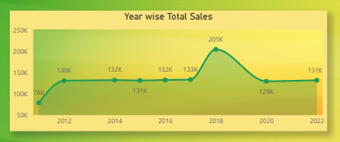

- Outlet Size – Donut Chart (shows distribution of outlet sizes).

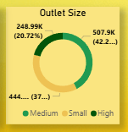

- Outlet Location – Stacked Bar Chart (Tier-wise outlet count or sales).

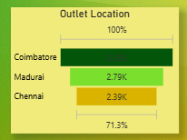

- Sales by Outlet & Fat – Stacked Bar Chart (comparison by outlet type and fat content).

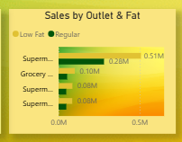

- Sum of Sales (by item type) – Bar Chart (horizontal bars for sales per category).

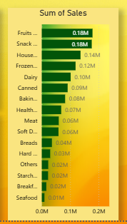

- Rating of Item type – Ribbon Chart (with Total Sales, Item type, Rating).

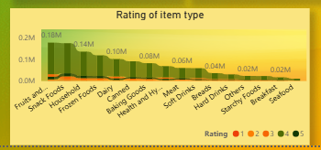

- Year wise Year Growth – Clustered Column Chart (with Establishment Year and Year wise Year Growth).

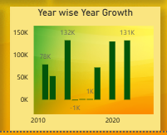

- Filters on the right – Slicers (for Outlet Location Type, Outlet Size, Item Type).

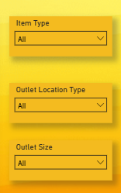
Conclusion

The Blinkit Grocery Power BI project provides a comprehensive analysis of sales performance, product trends, and outlet efficiency, enabling data-driven decision-making. By leveraging Power BI’s data visualization and modeling capabilities, the project successfully highlights key insights:
- Sales Trends & Performance:
  - Analysis of yearly sales identifies peak performance periods, helping in planning inventory and promotional strategies.
  - Total sales by item category, type, and outlet type reveal which products and outlets drive revenue.
- Outlet Insights:
  - The comparison of outlet sizes, location tiers, and types shows which stores are the most profitable.
  - This information can guide Blinkit in optimizing store operations and targeting high-performing outlets for expansion.
- Data-Driven Recommendations:
  - Focus on high-sales item categories and types to improve inventory and marketing strategies.
  - Prioritize investment in outlet types and locations generating the highest revenue.
  - Use year-over-year trends to forecast future sales and identify seasonal patterns.
- Technical Achievements:
  - Effective data transformation and data modeling were implemented using Power BI and XML data sources.
  - KPIs and DAX measures enabled dynamic reporting, providing interactive dashboards for quick insights.

Overall, this project demonstrates how Blinkit can leverage business intelligence to enhance operational efficiency, maximize sales, and support strategic growth decisions. The Power BI dashboard acts as a centralized tool for monitoring performance, analyzing trends, and making actionable business decisions.

